**Assignment 7 (work in pairs)**

You are to design and implement an animation program with the following scenario:

* Balls come out from both left and right edges of the frame (say, five from each side), and move horizontally.
* A ball becomes invisible when it hits the opposite side, or when it collides with a ball going opposite direction, in which case both balls become invisible.
* If a ball becomes invisible, a new ball is created, and flies out from the same edge as the invisible ball.
* Following is a snap shot of the frame; however, colors are optional.

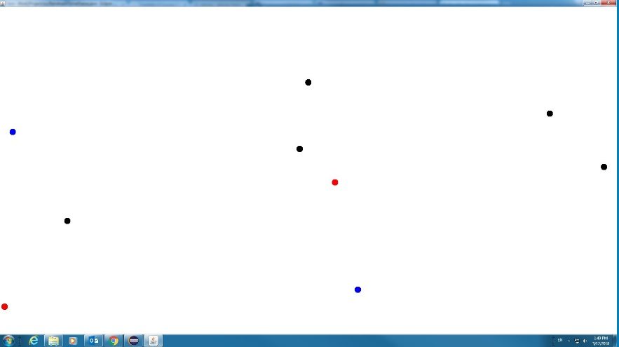

**Other requirements:**

Provide a C4 architectural view of the program. The level 1, 2, 3 views are probably trivial (nonetheless, you still produce them). For level-4 code view, diagrammatically describe how the program works. You can certainly use a sequence diagram or a communication diagram to do it. However, you can also use boxes and arrows to depict the logic flow of the program in your own way. You may use one diagram or multiple to enhance the clarity.

**Some hints:**

* Similar to the raindrop class we had, you probably need a Ball class (a ball is a filled circle). What should a ball be doing? It can set its vertical positon on left/right edge of the frame; it can move forward; it can draw itself; it can check on collision with the opposite edge; and it can check whether it is colliding with another ball (i.e., when their positions are close enough within certain threshold).
* You can mimic the structure of the example we had in class, thus you probably also need a *BallTask* class with methods that move balls and check collisions.

**Design consideration:**

It would be desirable to have a framework for such animation programs. With a framework, one only needs to swap out concrete classes for a different animation scenario, and the program otherwise remains virtually unchanged. How can we design such a framework? (*This is not a requirement, but an opportunity for extra credit.*)